Use-Case Realization Report (Analysis)
Add MCQ

Issue 1.0
Revision History
Date | Issue | Description | Author
01/Aug/09 | 1.0 | First Issue | Thomas Yap

Table of Contents
1. Brief Description 4
2. Flow of Events 4
2.1 Standard Flow 4
2.1.1 Add MCQ 4
2.2 Exception 4
3. Interaction Diagrams 5
3.1 Collaboration Diagram for Add MCQ 5
4. Participating Objects 5
5. Class Diagrams 6
5.1 Class Diagram for Add MCQ 6
6. Derived Requirements 6

Use-Case Realization Report
Add MCQ

Brief Description
This use case enables the controller to add new multiples choice question profile with its properties and parameters. It involves displaying the menu and form for keying in the MCQ details.

Flow of Events
The standard flow of events for this use case and any exceptions are described in the following subsections. The events are described in terms of Actors and Analysis Objects.

Standard Flow
This use case covers the MCQ Maintenance - Add MCQ. The standard flow of these events are described below.

Add MCQ
The running of the application is shown in section 3.1. The flow of event is as follow:

- When the application start, the first operation to be performed is the startup operation of the main controller. This operation will create all the control objects and the entity objects necessary for operation Add MCQ:
  - The control object created is: MCQ Controller
  - The entity objects create are: MCQ Table and Transaction Record

- The main controller will start the main function menu:
  - To start Add MCQ, operation FormAddMCQ is activated by MCQ Controller to display a MCQ form.
  - Portal Admin then input the data.
  - Operation validate will validate the format of the entries.
  - Then MCQController will check for duplication.
  - If no issue found, MCQ Controller will send a confirmation request to FormAddMCQ Interface.
  - Upon confirmation, the data will then be written to file using operation createMCQ to entity object MCQ Table.
  - In addition, a transaction log will be created by operation createRecord and store in entity TransactionRecord.
  - The adding request can be cancelled and no data will be stored.
  - A transaction record will still be created for traceability.
  - A confirmation message will be displayed by FormAddMCQ interface.

- Step 2 will be repeated until all new entries are added to the system. Then controller will terminate the application by issuing operation close.

Exception
None.

Interaction Diagrams

Collaboration Diagram for Add MCQ
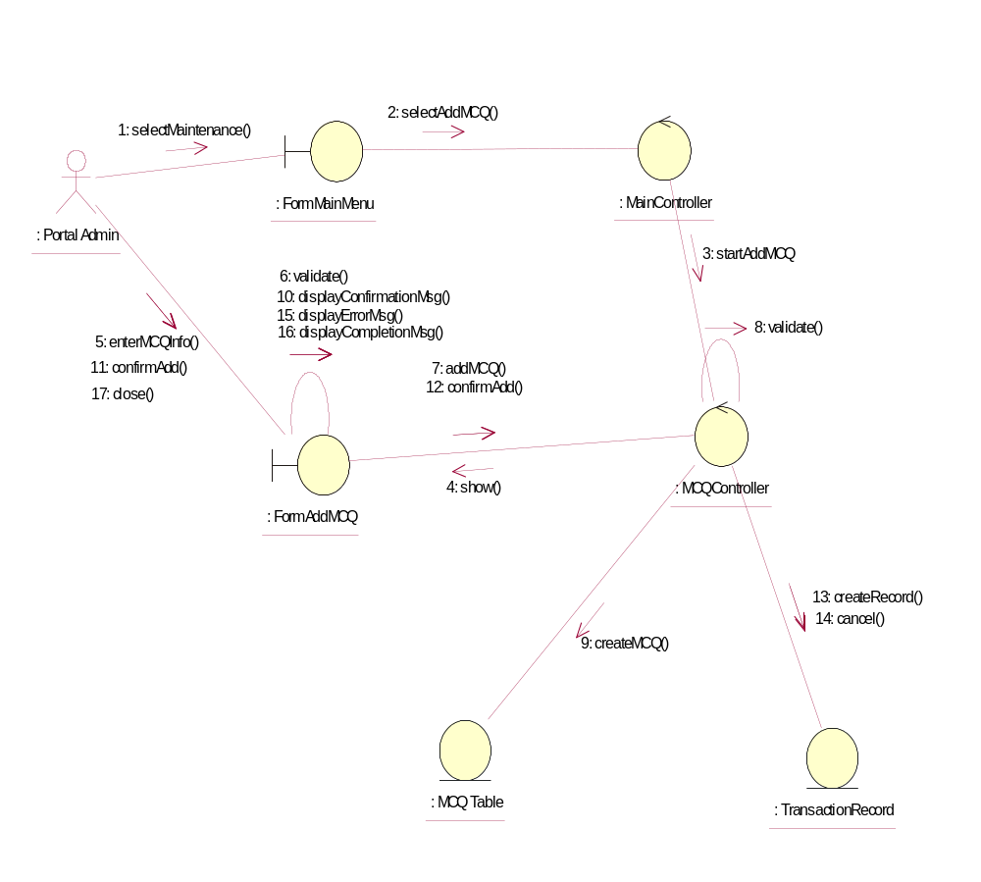

Participating Objects
: FormAddMCQ
This object is the interface for keying MCQ details.

: FormMainMenu
This is the main menu at the beginning of the application from where it can access the MCQ Maintenance - Add MCQ operation.

: MainController
This is the main controller that control the whole system.

: MCQ Table
This table stores all the properties and parameters of exam or exercise questions.

: MCQController
This is the controller for MCQ Maintenance. It creates and activates FormAddMCQ interface and MCQ Table.

: Portal Admin
This is the only actor that authorized to perform operation MCQ Maintenance - Add MCQ.

: TransactionRecord
This is the entity object that created for transaction log and audit trail.

Class Diagrams

Class Diagram for Add MCQ
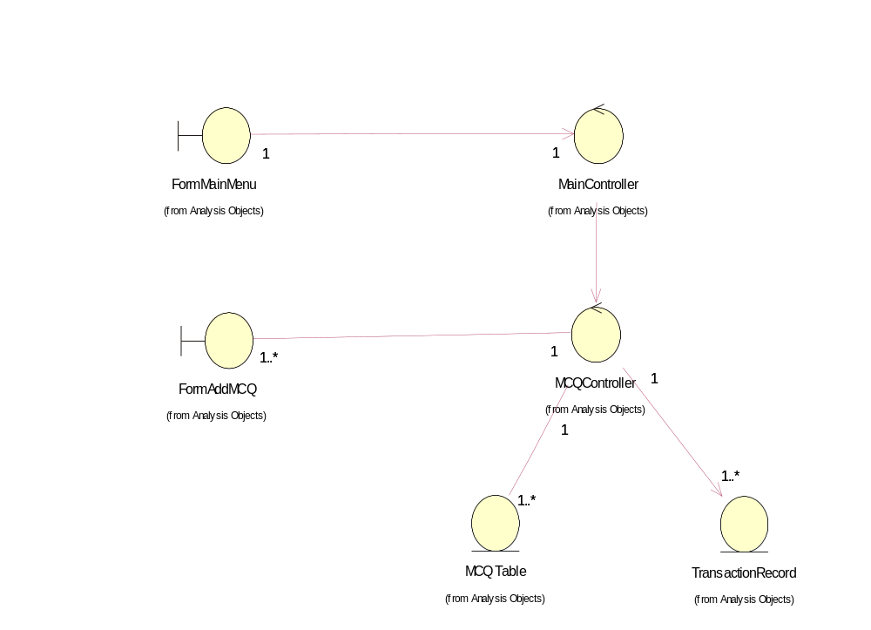

Derived Requirements
The FormMainMenu and FormAddMCQ Interface should have the format specified in User Requirements Specification for Content Management Portal.

